Project 2 – Whisky Discography

Team members:

* Matt Vella
* Alysha Snowden
* Stephanie Salvona
* Heriawan Muhamad

An in-depth analysis to the global whiskey market using the Whisky Hunter API to provide data to whisky drinkers and whisky wholesalers alike.

Data source: <https://whiskyhunter.net/api/>

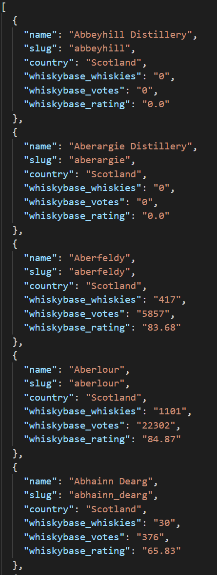 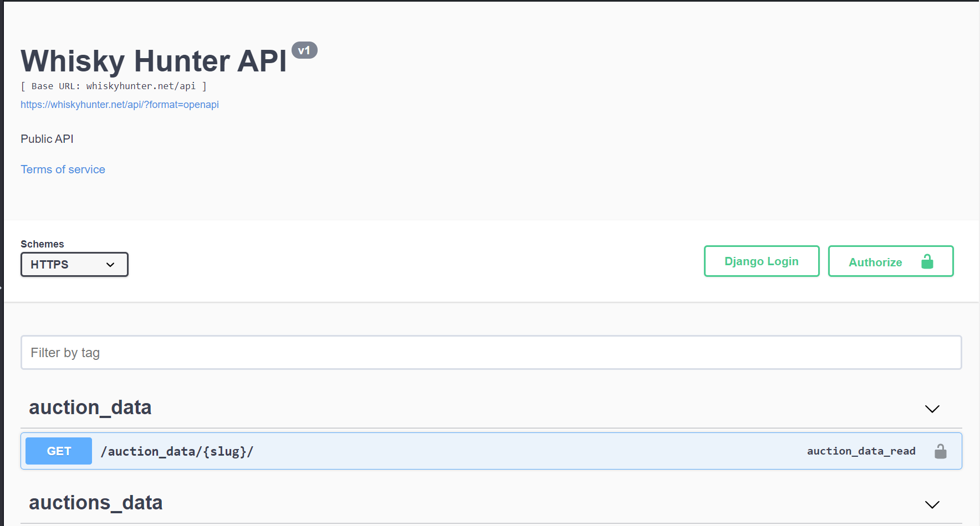

Examples of visualizations

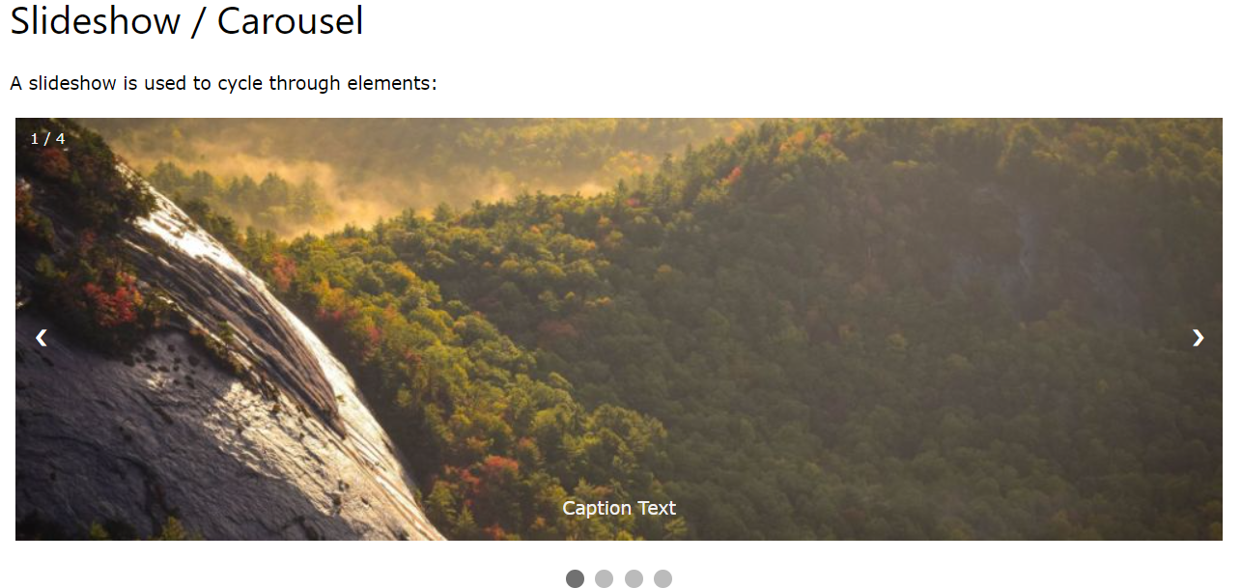

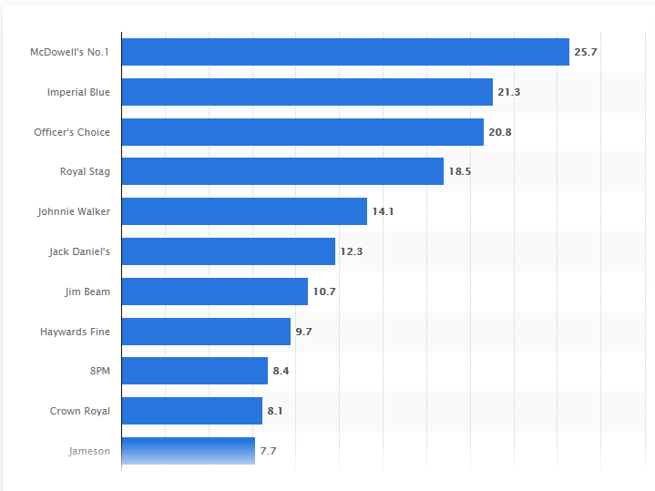

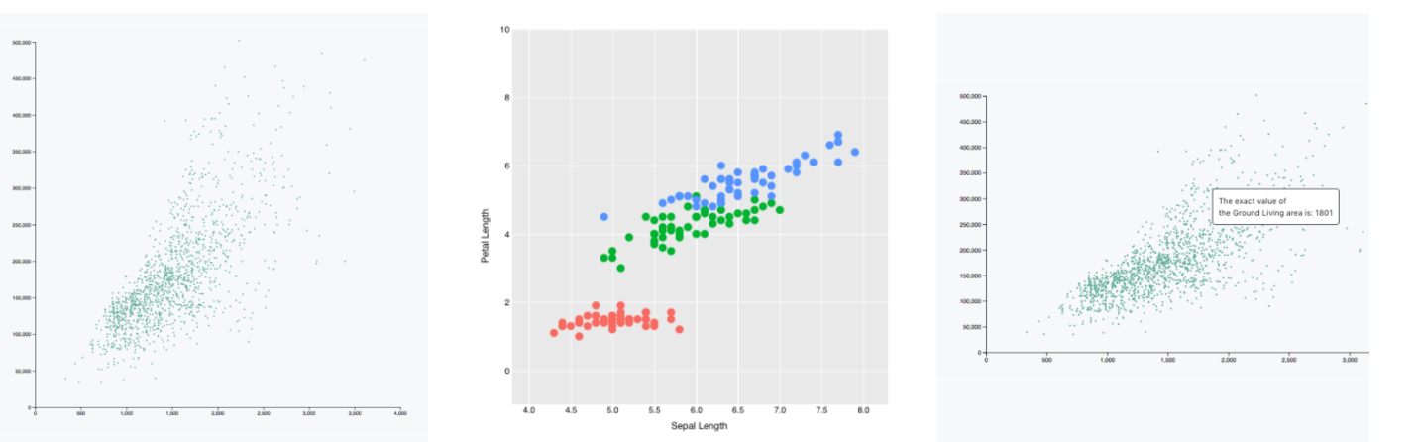

Wireframe sketch of site design

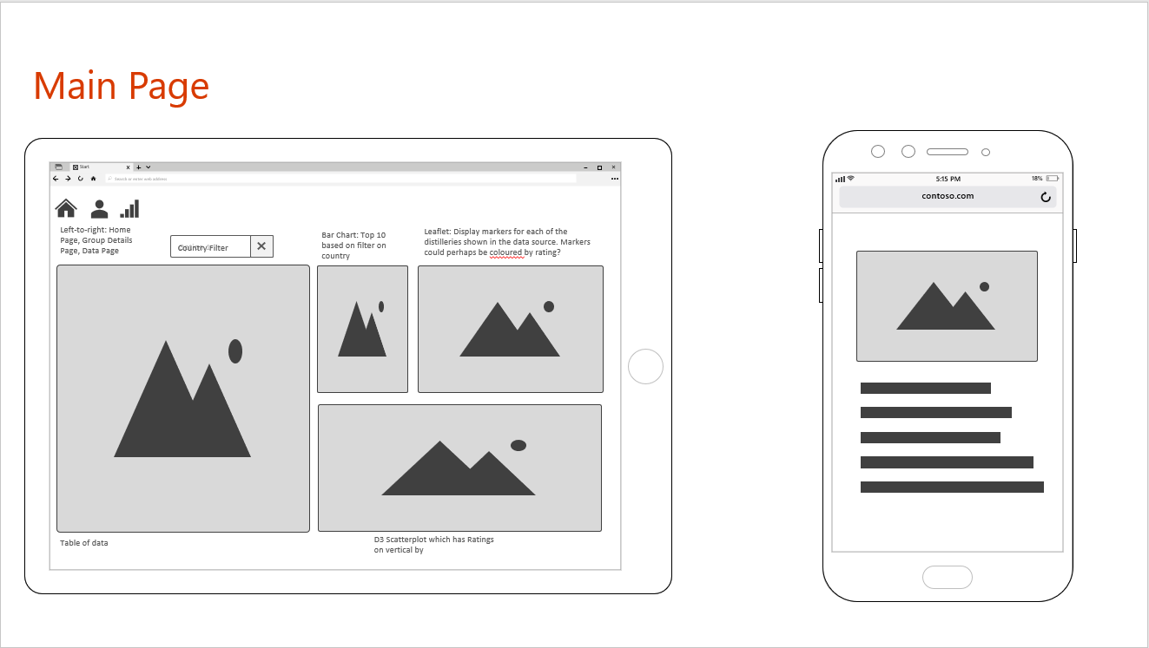

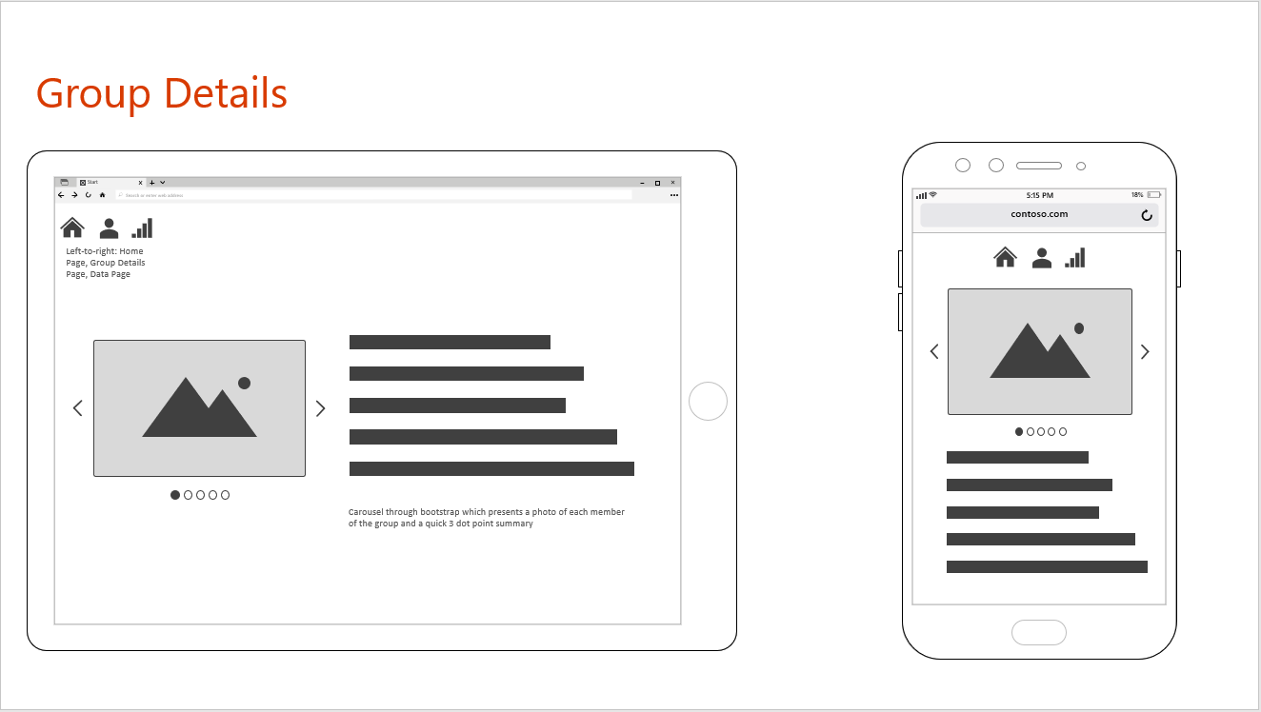

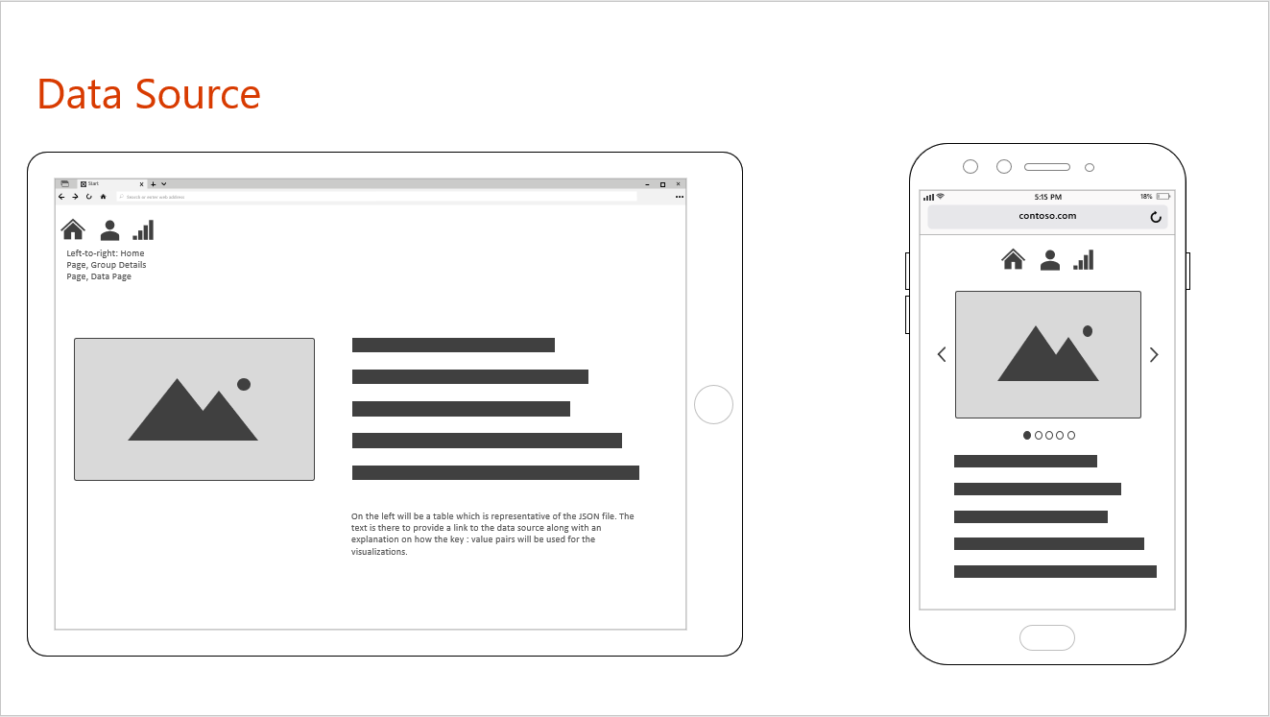

Link to project Github Repository

<https://github.com/EpicTomatoSauce/Whisky_Discography>